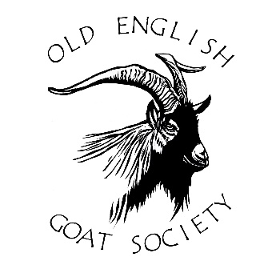

Hello everyone and welcome to your Autumn edition of the Newsletter. It is the time of the year that our thoughts turn to planning our herd for next year, selecting a male and looking forward to new life in spring. In this newsletter we have thoughts on testing! Both for disease and to enable us to get a better idea of the genetic make-up of our animals, and news of a welcome new herd of OE goats.

Looking for more OE goats?

One of our members is unfortunately looking to rehome her OE herd. Four wethers are looking for new homes, one is two years old, the other 3 are one year old. No charge for a good home. If you can help please get in touch with the editor on mojohnson195@gmail.com

Testing, testing…..

In the Summer edition of the newsletter, I mentioned we were testing our kids for Johnes, CLA and CAE at the request of a buyer and I was interested in hearing about experiences of testing from other members. Barbara le Gallez was kind enough to send the article below.

You asked about whole herd testing. Here is my experience (with Golden Guernsey and English) as I have no Old English (yet).

We first tested every year for CAE, then for two years we tested annually also for CLA and Johnes. Always with SRUC. I also test both the sheep that I own for the same diseases. Here is what has happened:

CAE - no problems.
CLA - each year, for 8 goats, we had 1 false +ve (a different goat each time) which tested -ve on retest. The goat showed now symptoms in either case. SRUC were not at all surprised by this, and said "it is a sheep test and you do get false +ves with goats". I don't plan to continue with CLA testing as I think this level of inaccurarcy is unacceptable.
Johnes - this year one of my goats, then aged nearly 3, tested +ve on the blood test and -ve on the poo test. Same result in July. She also shows no symptoms. The vet and I have doubts over the retest - the percentage was 213 in BOTH cases and this seems very unlikely. We are both aware that SRUC have a reputation for poor administration - I think they have sent the January result twice. So we are retesting with Axiom.

My opinion of whole herd testing is:
# a great way of combating disease, as long as the test is reliable.
# but pointless unless all sheep kept on the holding are also tested, as otherwise they could spread the diseases. I think this is mostly NOT done.
From Barbara le Gallez

I am pleased to report that all our kids returned negative for all three diseases, but it wasn’t a cheap experience at nearly £50 per kid. Is this something other keepers have done? Can you see testing like this becoming compulsory for goats as TB testing is for cattle? What is your opinion?
Please let me know.

More testing!
DNA Project
Well, you know that old adage about DNA projects: “You spend years saving for one, then two free ones come along at once!”
Having spent a great deal of time thinking about the How, What & Why of an Old English Goats genetic investigation – probably beginning with Cheviot goats as a “baseline” for British Primitives, and then perhaps moving onto other wild/feral populations – it was clear that it would be a very expensive project. Baselining the Cheviot goats would cost between £7,000 and £20,000 depending on the depth & breadth, and expanding that baseline to other wild (largely Scottish) populations would cost the same again. This would lead us finally to a point where we’d have enough relevant UK goat DNA data to undertake a meaningful study into the genetic makeup of our goats, at a probable cost of £10,000 to £15,000. Clearly that’s a great deal of time, effort, and cost – and I’m not 100% sure we’d know right now which are the most important questions we’re trying to answer with such a study.
What great news then, when SRUC Edinburgh contacted me with an offer to provide 60 DNA swab tests(almost identical to Covid-19 Lat-Flow tests) for free! The SRUC project is a bit unusual from our perspective, as it’s really a study into Nubian goats, but luckily for us they need to gather further goat breed data for comparison. SRUC were happy that, should we participate in the study, they would provide the digitised DNA data to us for later use. This was the key from our point of view. The SRUC study may not be telling us totally relevant things about our goats, but it would provide us with Gigabytes of DNA sequencing data for later studies. In another stroke of good fortune, once I’d explained the relationship between Old English Goats and the totally separate British Primitive breed, they were keen that a percentage of their swabs were used to test Cheviot goats. Good news all around then – 9 or 10 cheviot goats sampled, and 40 to 50 registered Old English goats sampled.
About a week before I was due to go around the country DNA swabbing some of our biggest herds, I had an invite to a meeting with Cardiff University from the RBST. It turns out that Cardiff were heavily involved in the recent study which determined that all goats originated from Northern Iran, not Northern Turkey as originally thought. As a continuation of their goat origins study, they now wanted to move on to study the origins of UK populations including; Golden Guernsey, Bagot, EGBA-English, and Old English. Once again I had to explain that British Primitives were a breed and about the history of the Cheviots and the gaps in knowledge on other wild/feral populations. Cardiff were incredibly excited by this news, as it tied in perfectly with their “origin of various goats” running theme. Cardiff were excited to go a little further than the SRUC sample-set. They certainly wanted Old English and Cheviot samples, but they were also keen for samples from other wild/feral populations. By using the deer stalking network, we’ve already managed to get 3 skin & hair samples from the Isle of Rum population of wild goats, and we’re working on others from Isla, Jura, and the Trossacks. We’ve also got access to 3 goatlings from the Dinorwig herd of feral goats in Snowdonia. As with the SRUC study, Cardiff are very happy to provide the digitised DNA data to us, for future use.
Whilst neither of these studies may tell us exactly what we want to know about our breed, they will provide us with a vast wealth of DNA data which we can build upon, allowing us to perhaps commission our own DNA study with academia (at much lower cost!). The Cardiff study should be very interesting in it’s own right, and it’ll be interesting to see what relationships they unpick between our goats, EGBA, and possibly even the bagots. We still have some DNA swabs remaining (from Cardiff), so we’re hoping we’ll be able to sample further Cheviot & feral goats this winter.
As soon as either study gives me an expected publication date, or some results, I’ll update you all again.
Exciting Times!
Adam Short
OEGS Registrar

New Old English Herd at Church Farm
Last winter three of our OE goats from Ferry House - Jenny, Ava and Aiofe - went on loan to Church Farm Rare Breeds Centre at Stow Bardolph in Norfolk. I wrote a bit about this in the Spring newsletter They went partially to get them away from our amorous billy goat – Willowcroft Odin, but mainly so that Church Farm could see if OE goats would fit into their farming system and help to eat off nettles and thistles, helping to reduce the use of expensive and environmentally damaging herbicides. The Rare Breeds Centre already have Bagots, Golden Guernseys and Pygmy goats, but OE’s were high on their list of rare breeds to acquire and chances of buying registered goats were slim in 2021 when the ‘Waiting list’ was in operation.
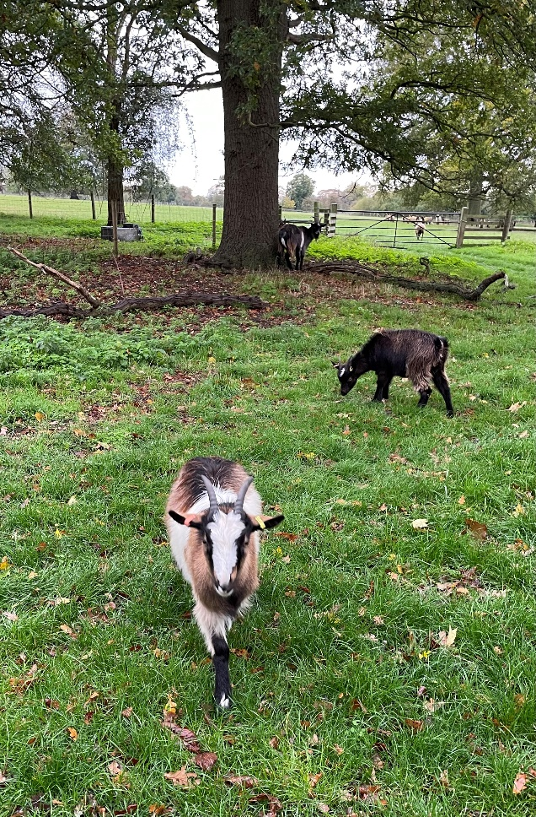
The wide open spaces of Church Farm for Bea (front) and Bella to enjoy
The three goats settled in beautifully alongside some primitive sheep and became firm favourites with the animal keepers. They lived in beautiful parkland, scattered with huge mature sweet chestnut trees, and hedges, providing lots of browsing and shelter in even the coldest weather. I was a little concerned about Jenny in particular because she had developed a neurological condition during her first pregnancy, which had severely weakened one of her back legs, but she thrived and grew sleek and very hairy over the winter and spring.
In July 2022 the three returned to Ferry House, Ava and Aiofe in order to become part of our breeding herd, but Church Farm eventually prevailed upon me to let our last two 2022 female kids go to live at Church Farm permanently. Along with two of our wethers – Amos and Ve - for company, Ferry House Bea and Ferry House Belladonna will now form the basis of the Church Farm Old English herd.
They will be joined shortly by Templeton Cicero, who will become the Church Farm stock OE billy. Cicero is currently at Ferry House, romancing our four breeding girls, but he is also a good genetic match for Bea and Belladonna, and other female Old English in the East Anglia region, so he was well worth the 10 hour round trip to collect him from Temple Farm in Devon!
This sort of collaboration with the Rare Breed centre has been very advantageous. It gave them the chance to see if the OE goats suited their farm before committing to ownership and there was also a chance to discuss pros and cons of different management systems, to everyone’s benefit. Although it was difficult to let the kids go, it is great to see another OE herd established and to know that Cicero will be at stud there next year when we will be able to use him again for our breeding females.
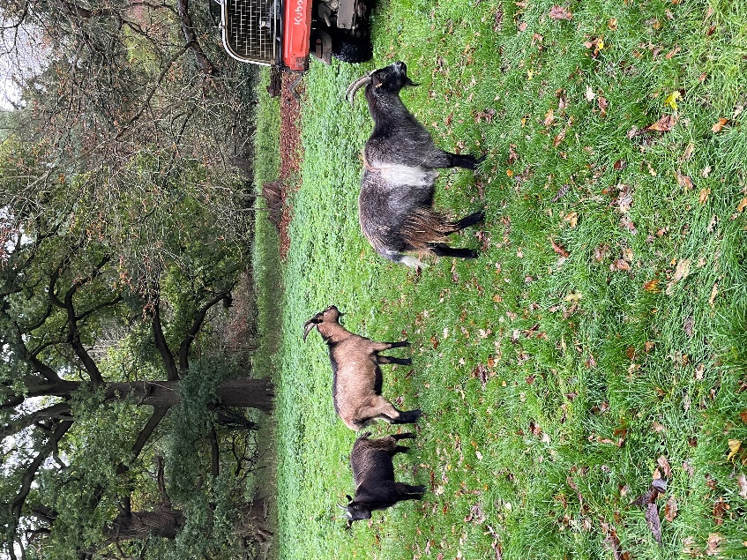
OE wethers Amos (brown) and Ve (grey) make up the rest of the herd at Church Farm
We would love to know about where your kids have gone to, or if you are a new keeper just starting out with your own new OE herd – please email me to tell your story!
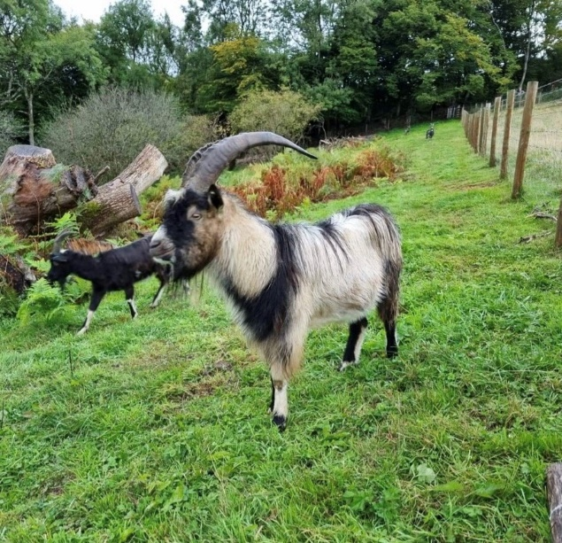

The lovely Templeton Cicero (photo by Adam Short)

Officers’ Contact Details.
Chairman: Anne Rogers, Brynawel, Pembrokeshire, SA66 7HN
aannerogers@hotmail.co.uk
07768966687

The Secretary: Eleri Pugh. Temple Farm, Templeton. Tiverton. Devon EX16 8BL
Eleri@temple-farm.co.uk 07947140848
The Treasurer: Shirley Goodyer. Woodcroft, Acton Rd. Esh Winning. Durham DH7 9PL
Lesandshirleygoodyer@gmail.com
Registrar :
Adam Short. Temple Farm, Templeton. Tiverton. Devon EX16 8BL
adam@temple-farm.co.uk
Newsletter editor and Year Book:
Maureen Johnson. Ferry House, London Road, Chatteris. Cambridgeshire PE16 6SG
Email: mojohnson195@gmail.com 01354 462001
Committee members: Charlie Parker. Hillgill Farm, Baldersdale. Barnard Castle. Co.Durham DL12 9UX 01833 367588
administrator@daleslogger.com
Thelma Rowell, West Chapel House, Chapel-le-Dale. Ingleton via Carnforth LA6 3JG
thelma.rowell@googlemail.com 01524 241392
Breed researcher and historian: Raymond Werner. 296, Church Rd. Mitcham. Surrey CR4 3BD

